Algebra Lesson Plans -Week 3 Aug.27th -31st

MONDAY: Chapter 1.5 EQUATIONS
TSW: Solve equations with one or two variables.
Activity: DVMA Warm-up, P.31-33 Notes (specifically review #66 & #70); P.34 #1-10 all
Assessment: Discussion, whole group Q & A, Independent work
HW: P.34 #11-35 Odds and #61

TUESDAY: Chapter 1.6 RELATIONS
TSW: Represent relations in multiple ways: ordered pairs, tables, graphs, and maps.
Interpret graphs.
Activity: DVMA Warm-up; P.38-40 Notes; P. 41 #1-8 All and #32 and #41 whole group.
Assessment: Observation; Homework; Discussion
HW: P. 41 #9 - 19 Odds and #27 - 31 Odds

WEDNESDAY: Chapter 1.7 FUNCTIONS
TSW: Determine whether a relation is a function and find function values.
Activity: DVMA Warm-up; P.45-48 Notes; P.49 # 1-19 All;
Assessment: Observation; Homework Review; Q&A; Group Work
HW: P.50 # 21- 41 Odds

THURSDAY: Chapter 1.8 LOGICAL REASONING
TSW: Identify the hypothesis & conclusion of a conditional statement.
Create counter examples to prove assertions false.
Activity: DVMA Warm-up; P.54-56 Notes; SmartBoard Interactive in small groups;
Assessment: Class Discussions; Observation; Quiz 2
HW: P.56 # 1-13 ALL

FRIDAY: CHAPTER REVIEW
TSW: Review Chapter 1 Material in preparation for chapter test on Monday.
Activity: SmartBoard Interactive using the Online Glencoe Review;
Pgs. 62-66 Group Work/ presentation.
Assessment: SmartBoard and Group Presentations
HW: STUDY FOR CHAPTER TEST ON TUESDAY! Have a great weekend

STANDARDS COVERED THIS WEEK: A.CED.1; A.REI.1&3&10; F.IF.1&2&5&9 (See next page for details)
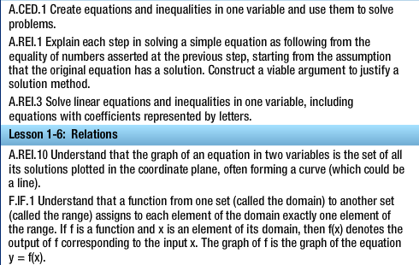
Lesson 1-5: Equations

