Algebra Lesson Plans - Week 11 Oct. 22th - 26th

MONDAY: Chapter 4.3 & 4.4 Review
TSW: Review key concepts of linear equations, parallel and perpendicular lines.
Activity: SmartBoard Interactive; Q &A;
Assessment: Smart Board Interactive; Observation; Q&A
HW: Self-Check Quiz 4.3 and 4.4

TUESDAY: Chapter 4.4 Extention
TSW: Write an equation of the line that passes through a given point and
is either parallel or perpendicular to a given line.
Activity: Warm-up; HW Review; Interactive Classroom at SmartBoard;
Quiz 2 Practice (not for a grade)
Assessment: Observations from activities; Q & A; Quiz 2
HW: Handout p.471-472 Circled questions only

WEDNESDAY: Chapter 4.5 Scatter Plots & Lines of Best Fit
TSW: Investigate relationships between quantities by using points on a
scatter plot. Use lines of fit to make and evaluate predictions.
Activity: HW Review; Personal Tutor Video Examples; Interactive Smart Board
lesson; Notes;
Small groups p.250 #11 Collect data and create a scatter plot then find the line of fit,
finally finding the equation of that line and making a conjecture based upon it.
Assessment: Smart Board and Small Group responses
HW: P. 244 Practice Mid-Chapter Test Odds

THURSDAY: NO CLASS (1/2 day schedule- Period 6 Fri.)

FRIDAY: HALF DAY SCHEDULE
TSW: Demonstrate their understanding of linear equations in all forms and
their graphs.
Activity/Assessment: MID-CHAPTER TEST (Lessons 1-4)
HW: NONE – HAVE A GREAT WEEKEND!
STANDARDS COVERED THIS WEEK: (See details below)
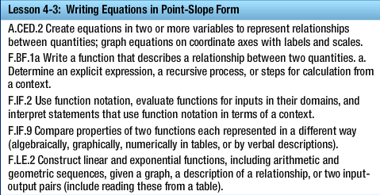

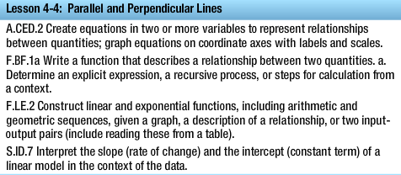

LESSON 4-5